Gucci Belts – Five That Are In Trend Right Now
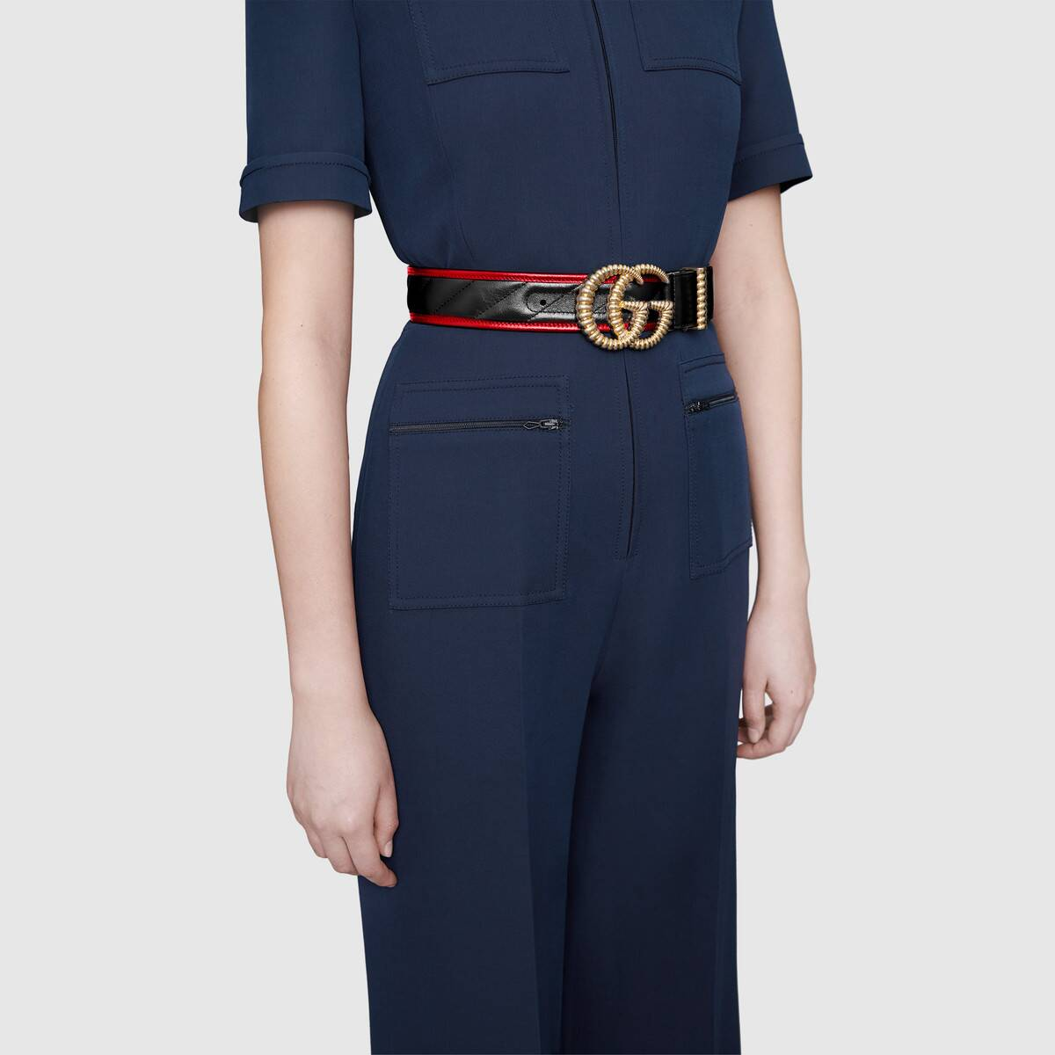
The eponymous Gucci buckle sits symmetrically and a little bulkily under the navel like some gold on-button that needs pressing to open a secret vault. The strap is frequently black or gold. Or the deep red and green of English horse riding tradition - colours that (if you follow internet style guides) don’t always sit right together.
To wear Gucci (and particularly something as ostentatious as the Gucci belt) is - to a large extent - a matter of overcoming the fear of wearing Gucci in the first place. But the clothing item itself - a portal to that secret place where Gucci plays mind trips on luxury, rebellion and decorum – is an empowering fashion item only once you wear it.
The uninitiated dare to call the Gucci vision of style vulgar because of the profusion of deeper, darker colours, elaborate ornamentation and embroidery; elements that challenge what is tasteful and what – in a room full of trendy aspirers or black-on-dark-grey achievers – should count as acceptable in the first place.
And the belt - the ostentatious accessory that brazenly crowns the pelvis, that points up to all good things Italian - is too showy for some.
What’s in a Belt?
Alternatively belts, unlike more noticeable accessories (the ones that can move like bags and shades), are a sometimes forgotten commodity in the fashionable woman’s getup (How often does, “I love your belt” happen?)
But aside from its utility (years of steady service that might outdo a pair of quality shoes) it’s also a vital accessory that differentiates you from the soft punchers in the smarter, oxygen-starved heights where style battles are a do-or-die matter.
In terms of the real arenas, what better place to start than the workplace. Our first Gucci contestant, ready for a fight that it really can’t lose …
GG Marmont Belt with Shiny Buckle
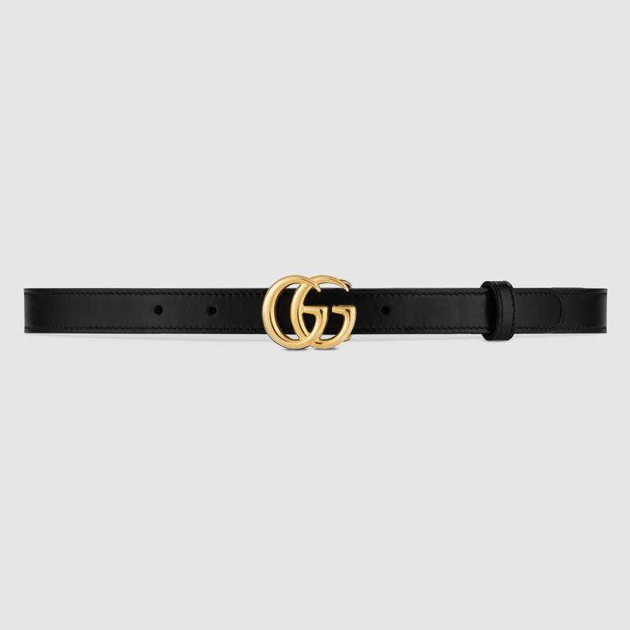
This is the model that counterfeiters cast their crooked eye over to bring you an almost identical model that is a little duller in the leather, a little shinier in the metal, and poorly embossed and packaged.
But these belts are ripped for good reason: it’s the simplicity of the Marmont that makes it the pretender’s band of choice, and if work is a necessity for you, figure you might be starved to opt for the real deal, and what’s the difference anyway?
Wrong thinking. The larger version is the one you wear to support a pair of jeans under a leopard print shirt. The slimmer version here, done right, looks classier splitting classy work slacks. And, because it’s demure, people will never question its authenticity.
Elastic Belt with crystal Double G Buckle
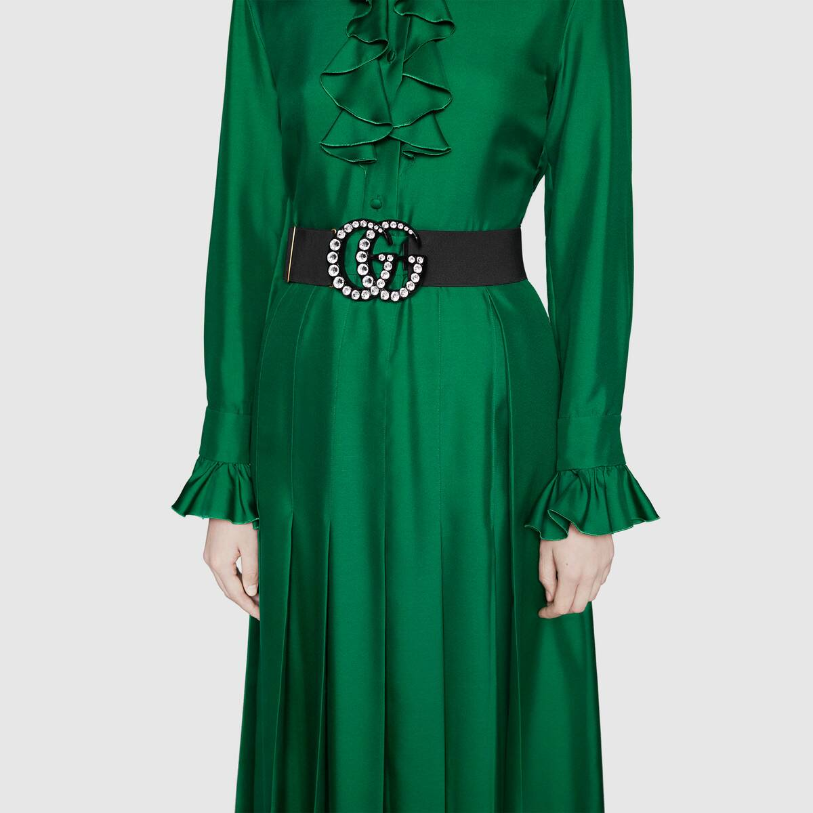
But sometimes, you do need to make an assertive entrance. A wider belt is – in effect – a waist emphasizer and - as it splits the upper and lower silhouette - is a great way to bring contrast or relief to very long or complex garments. It also emphases individual elements (neckline, buttons) up to the face, eyes and hair. Gucci makes the large crystal belt in multiple colours, but black draws in all the rich dress tones, while the crystals – lit up like champagne kisses – say you’re not taking this fashion thing too seriously.

Web elastic belt with torchon Double G buckle

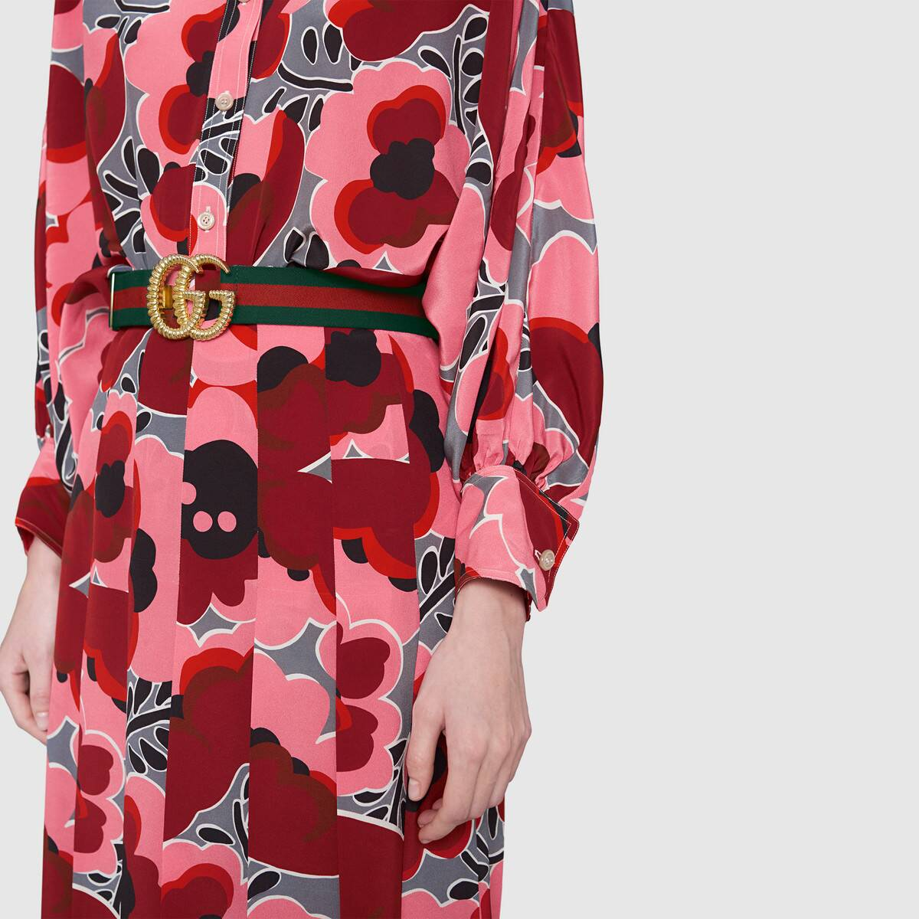

Or you can strap something more traditional (Gucci saddle-bit red and green is as recognisable as Armani grey) between the loops of your shredded denim jeans and under your black shirt and blazer. You’ll look energized.
Better yet, you can radicalize the whole show with a counter-intuitive pattern dress (that hints at one of the belt’s core colours), or a skirt/jacket in solemn Gucci tan. Folks are going to see you coming a mile off, but will be too intimidated to look you down. That’s the whole point of Gucci really: you enter strong with colours mixed to seduce or overpower. Your red, gold and green number manages all this in elastic.

Chain Belt with Lion’s Head

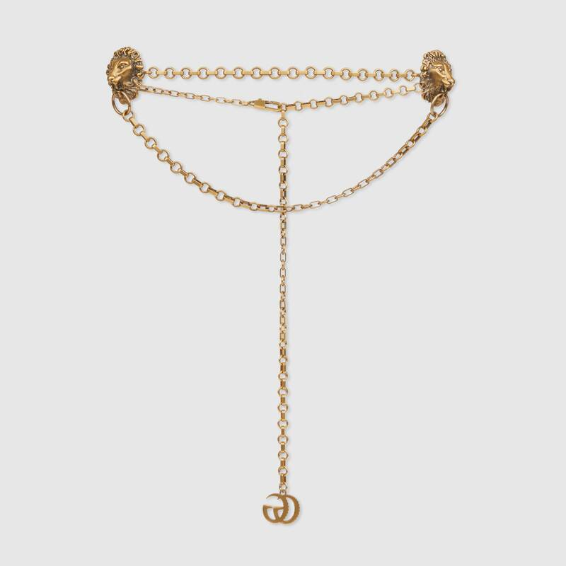

Eventually you have to get back to work. You could wear the standard Marmont six days a week. You’ll ooze class and own the stroll to the weekly meeting. Or you could run the room with alpha-feline backup. Girded to the waste or louche to the hips in gold, the chain belt nods to Italy’s classical past that elevate regality and feminine sexuality.
The lions themselves are a reference to the Chimera of Arezzo – a bronze artwork created by the earliest settlers in Tuscany. But the Gucci mind-set isn’t bindingly referential. You could easily drape this belt through cream leggings for strong Tuscan Luxe, or bind it to a rouge or deep green patterned dress for freer spirited references of your own design.
Web Belt with Bee
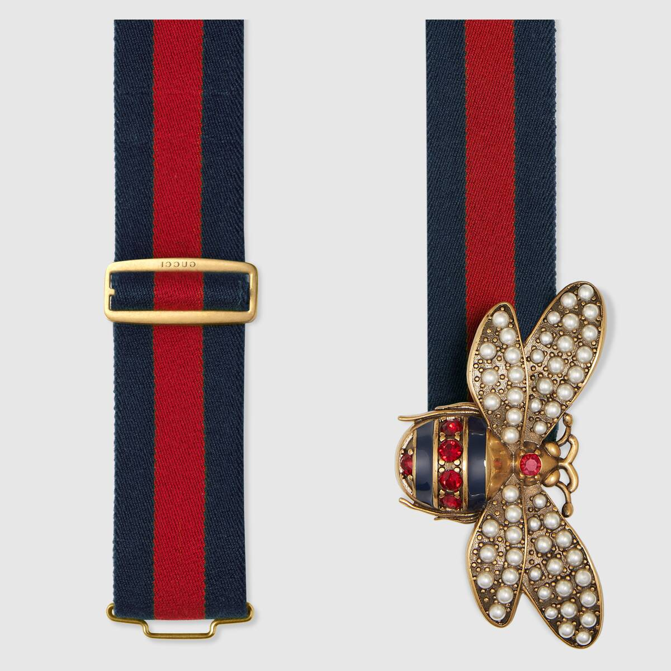

Ornate and opulent expressions of personal style have always been Gucci’s modus operandi, which distinguishes the label from the camp inclinations of Moschino or Versace, the modernism of Armani, or the subtler (and frequently more streamlined) flourishes of the French catwalk. The bee symbolism – a bold over-oversized buckle – is all for show and taps into stylistic edicts that make Gucci’s take on fashion such a no-compromise affair.
Both anti-establishment medallion and billionaire trinket, either set would appreciate Alessandro’s Michelle’s nod to the environment and the Tuscan heartland. We should also remember that bees are striped and beautiful, that they believe in a female god and that once they exact force, they die. The Gucci sting – to die for!
Your Take on Gucci
Five belts that forward your personal style whilst also being unapologetically of the Gucci stable. Wearing Gucci should never make you a logo-courier, and neither should you allow the brand to completely determine what statement you will make. Done right, Gucci is a luxurious conundrum you’ll be devoted to solving, whilst knowing you’ll be dressed like art while you try.

977 words

